How to Upload Your Video to Onedrive

1. Record your video with your preferred recording software
2. Upload your video to your FGCU OneDrive Account
   1. How to download and install Office 365 on a personal device : <https://fgcu.zendesk.com/hc/en-us/articles/360039012552-How-to-download-and-install-Office-365-on-a-personal-device>
   2. How Upload and save files and folders to OneDrive Web: <https://fgcu.zendesk.com/hc/en-us/articles/360039469332-Upload-and-save-files-and-folders-to-OneDrive-Web>
3. Create a Link to share your video
   1. With a file open or a file or folder selected, select Share.
      1. OR in the folder select the share icon to the right of the video title.
   2. Select the arrow to the right of “Anyone with a link can edit” to adjust your settings:
      1. Under “Who would you like this link to work for?” Select “people in Florida Gulf Coast University with the link.”
      2. Your settings should look like this:

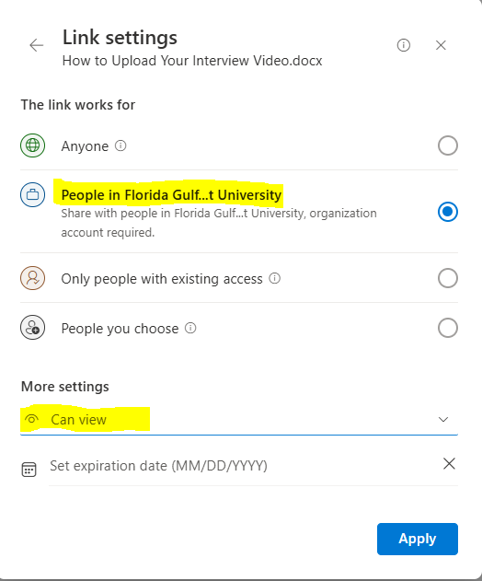

* + 1. Click “Apply” to save the permissions. 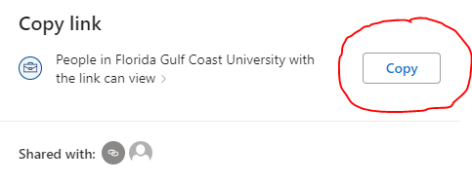
  1. Select “Copy” underneath “Copy Link”

1. Paste your link into the discussion.

\*\*\*DO NOT DELETE THE VIDEO FROM YOUR ONEDRIVE, DOING SO WILL SEVER THE LINK AND THE VIDEO WILL NOT BE VIEWABLE TO YOUR CLASSMATES\*\*\*